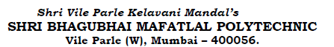

**Statement of account for the purchase of components for Drone project:**

|  |  |  |  |
| --- | --- | --- | --- |
| S.No | Particulars | Quantity | Amount |
| 1 | Pluto X Tinkerer Kit | 1 | 20424.00 |
| 2 | Propellers - Black | 1 | 400.00 |
|  | **Total** |  | **20824.00** |

**Payment to be made to:**

|  |  |  |  |  |
| --- | --- | --- | --- | --- |
| S.No | Roll No | Name, Phone No. | Amount | Amount in words |
| 1 | T118 | Mr Mihir Panchal,  9833371632 | Rs 20824.00 | Twenty thousand eight hundred and twenty four only |

Department Coordinator Mrs. A. A. Kulkarni Dr. M. Z. Shaikh

HOD Electronics Principal

Enclosure: 1. Bills

2. Approval from SVKM’s OB decision